**Ideation Phase**

**Brainstorm & Idea Prioritization**

|  |  |
| --- | --- |
| Name | Keerthana. E |
| Team ID | PNT2022TMID26833 |
| Project Name | Personal Assistance for senior citizens who are self-reliant |
| Maximum Marks | 4 Marks |

**Brainstorm & Idea Prioritization:**

**Step-1: Brainstorm, Idea Listing and Grouping**

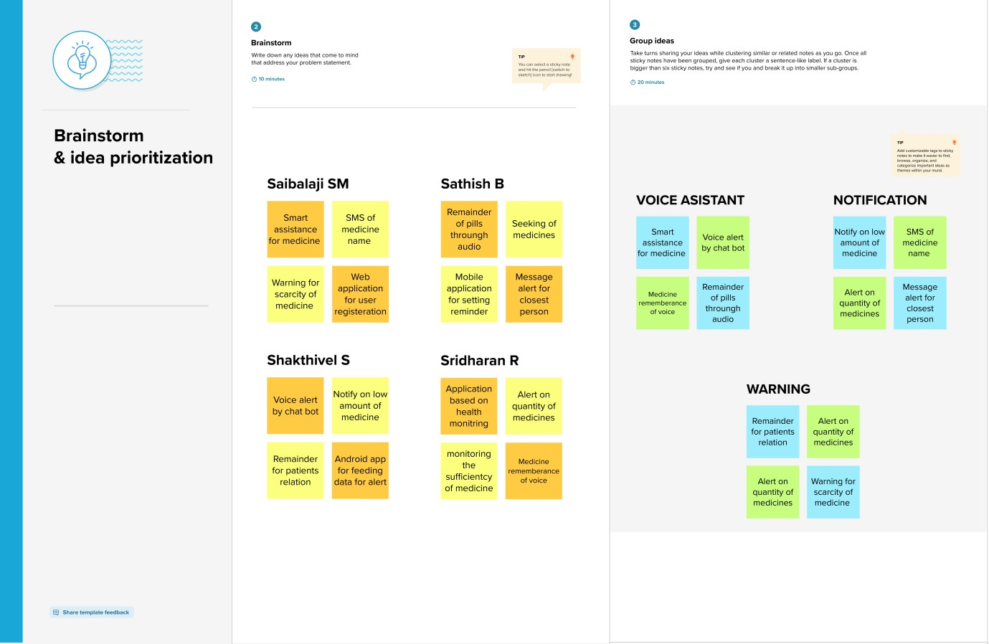

**Step-2: Idea Prioritization**

